**Testing of Gatekeeper/Ballot Events (via cURL and hardcoded data)**

1. Deployment of the Dao adding the testing accounts was successful. The three testing accounts are at the end of this document for reference.

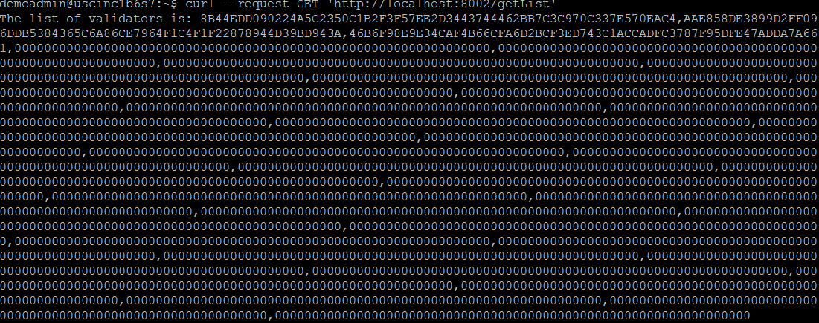

Testing Accounts

**Account 1**

String of public key is: 0373ecbb94edf2f4f6c09f617725e7e2d2b12b3bccccfe9674c527c83f50c89055

String of private key is: 66cdd508f950d08e02d8448c55a03c14e08e9a3447c4361105e14ad32ec3286a

Message hash string: 7624778dedc75f8b322b9fa1632a610d40b85e106c7d9bf0e743a9ce291b9c6f

sig string is: c21bb2c81d0ca548a59b61a6d9fdc3871b867a951963e059a1862f829e4f835a5a0584405f64288ca6315d871efc4d7c39a625c5eb01108f2ddb49e37a711515

**Account 2**

String of public key is: 03683536757fdb821c10810b51caa51a84fc1dfab5c17edbf5246f9713ffe31adf

String of private key is: f4822c62077945009cd816e479eef4ac371613d2d44164fc7ecaa93f180f2eb4

Message hash string: 7624778dedc75f8b322b9fa1632a610d40b85e106c7d9bf0e743a9ce291b9c6f

sig string is: 9a83145f3533169aea22d253ee30533768f112b0818d096716f7d6ef664d95ea4c8e2e548c57d0142b82ce85403d307cb817a9d9e7b64e088d8c4b08d551eab4

**Account 3**

String of public key is: 03a066efbb37f5fabfab05bf4a65e0dc376d0e3fb1c3d930d7f5ec6da3ac5bc237

String of private key is: 2eff28029dced258c4aca03415fd3ef201ec118e57241b758e82454a6bc75cd4

Message hash string: 7624778dedc75f8b322b9fa1632a610d40b85e106c7d9bf0e743a9ce291b9c6f

sig string is: 9337df4f95d3460dea440315c17666ebef89db10d19760ee3277c4fd1fafed7d1e3b1a8b7822bb8374de88b3b50305d7d94d14377b8b0945f1180a8db45bd0b4